
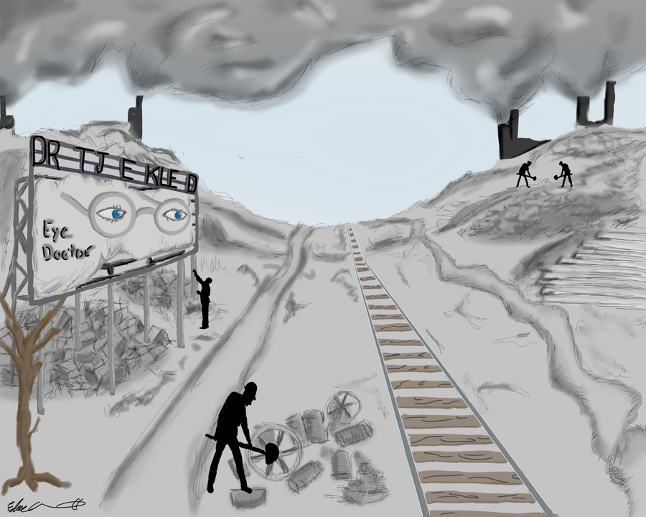
F. Scott Fitzgerald’s
The Great Gatsby
READ BY DATE

CH. 1: Pages 1-21
A Day: Wed Jan 8
B Day: Thurs Jan 9

CH. 2: Pages 23-38
A Day: Fri Jan 10
B Day: Mon Jan 13

CH. 3: Pages 39-59
A Day: Tues Jan 14
B Day: Wed Jan 15

CH. 4: Pages 61-80
A Day: Thurs Jan 16
B Day: Fri Jan 17

CH. 5: Pages 81-96
A Day: Tues Jan 21
B Day: Wed Jan 22

CH. 6: Pages 97-111
A Day: Thurs Jan 23
B Day: Fri Jan 24

CH. 7: Pages 113-145
A Day: Mon Jan 27
B Day: Tues Jan 28

CH. 8: Pages 147-162
A Day: Wed Jan 29
B Day: Thurs Jan 30

CH. 9: Pages 163-180
A Day: Fri Jan 31
B Day: Mon Feb 3

Paper 2 Unit Assessment
A Day: Mon Feb 10
B Day: Tues Feb 11

Sample IB Paper 2 Question: The memorable impact of novels and short stories arises from the careful and often brilliant creation of detail by their writers. Explore the role and impact of some significant details in the narrative.


F. Scott Fitzgerald’s
The Great Gatsby
READ BY DATE

CH. 1: Pages 1-21
A Day: Wed Jan 8
B Day: Thurs Jan 9

CH. 2: Pages 23-38
A Day: Fri Jan 10
B Day: Mon Jan 13

CH. 3: Pages 39-59
A Day: Tues Jan 14
B Day: Wed Jan 15

CH. 4: Pages 61-80
A Day: Thurs Jan 16
B Day: Fri Jan 17

CH. 5: Pages 81-96
A Day: Tues Jan 21
B Day: Wed Jan 22

CH. 6: Pages 97-111
A Day: Thurs Jan 23
B Day: Fri Jan 24

CH. 7: Pages 113-145
A Day: Mon Jan 27
B Day: Tues Jan 28

CH. 8: Pages 147-162
A Day: Wed Jan 29
B Day: Thurs Jan 30

CH. 9: Pages 163-180
A Day: Fri Jan 31
B Day: Mon Feb 3

Paper 2 Unit Assessment
A Day: Mon Feb 10
B Day: Tues Feb 11

Sample IB Paper 2 Question: The memorable impact of novels and short stories arises from the careful and often brilliant creation of detail by their writers. Explore the role and impact of some significant details in the narrative.

F. Scott Fitzgerald’s
The Great Gatsby
READ BY DATE

CH. 1: Pages 1-21
A Day: Wed Jan 8
B Day: Thurs Jan 9

CH. 2: Pages 23-38
A Day: Fri Jan 10
B Day: Mon Jan 13

CH. 3: Pages 39-59
A Day: Tues Jan 14
B Day: Wed Jan 15

CH. 4: Pages 61-80
A Day: Thurs Jan 16
B Day: Fri Jan 17

CH. 5: Pages 81-96
A Day: Tues Jan 21
B Day: Wed Jan 22

CH. 6: Pages 97-111
A Day: Thurs Jan 23
B Day: Fri Jan 24

CH. 7: Pages 113-145
A Day: Mon Jan 27
B Day: Tues Jan 28

CH. 8: Pages 147-162
A Day: Wed Jan 29
B Day: Thurs Jan 30

CH. 9: Pages 163-180
A Day: Fri Jan 31
B Day: Mon Feb 3

Paper 2 Unit Assessment
A Day: Mon Feb 10
B Day: Tues Feb 11

Sample IB Paper 2 Question: The memorable impact of novels and short stories arises from the careful and often brilliant creation of detail by their writers. Explore the role and impact of some significant details in the narrative.



F. Scott Fitzgerald’s
The Great Gatsby
READ BY DATE

CH. 1: Pages 1-21
A Day: Wed Jan 8
B Day: Thurs Jan 9

CH. 2: Pages 23-38
A Day: Fri Jan 10
B Day: Mon Jan 13

CH. 3: Pages 39-59
A Day: Tues Jan 14
B Day: Wed Jan 15

CH. 4: Pages 61-80
A Day: Thurs Jan 16
B Day: Fri Jan 17

CH. 5: Pages 81-96
A Day: Tues Jan 21
B Day: Wed Jan 22

CH. 6: Pages 97-111
A Day: Thurs Jan 23
B Day: Fri Jan 24

CH. 7: Pages 113-145
A Day: Mon Jan 27
B Day: Tues Jan 28

CH. 8: Pages 147-162
A Day: Wed Jan 29
B Day: Thurs Jan 30

CH. 9: Pages 163-180
A Day: Fri Jan 31
B Day: Mon Feb 3

Paper 2 Unit Assessment
A Day: Mon Feb 10
B Day: Tues Feb 11

Sample IB Paper 2 Question: The memorable impact of novels and short stories arises from the careful and often brilliant creation of detail by their writers. Explore the role and impact of some significant details in the narrative.

F. Scott Fitzgerald’s
The Great Gatsby
READ BY DATE

CH. 1: Pages 1-21
A Day: Wed Jan 8
B Day: Thurs Jan 9

CH. 2: Pages 23-38
A Day: Fri Jan 10
B Day: Mon Jan 13

CH. 3: Pages 39-59
A Day: Tues Jan 14
B Day: Wed Jan 15

CH. 4: Pages 61-80
A Day: Thurs Jan 16
B Day: Fri Jan 17

CH. 5: Pages 81-96
A Day: Tues Jan 21
B Day: Wed Jan 22

CH. 6: Pages 97-111
A Day: Thurs Jan 23
B Day: Fri Jan 24

CH. 7: Pages 113-145
A Day: Mon Jan 27
B Day: Tues Jan 28

CH. 8: Pages 147-162
A Day: Wed Jan 29
B Day: Thurs Jan 30

CH. 9: Pages 163-180
A Day: Fri Jan 31
B Day: Mon Feb 3

Paper 2 Unit Assessment
A Day: Mon Feb 10
B Day: Tues Feb 11

Sample IB Paper 2 Question: The memorable impact of novels and short stories arises from the careful and often brilliant creation of detail by their writers. Explore the role and impact of some significant details in the narrative.


F. Scott Fitzgerald’s
The Great Gatsby
READ BY DATE

CH. 1: Pages 1-21
A Day: Wed Jan 8
B Day: Thurs Jan 9

CH. 2: Pages 23-38
A Day: Fri Jan 10
B Day: Mon Jan 13

CH. 3: Pages 39-59
A Day: Tues Jan 14
B Day: Wed Jan 15

CH. 4: Pages 61-80
A Day: Thurs Jan 16
B Day: Fri Jan 17

CH. 5: Pages 81-96
A Day: Tues Jan 21
B Day: Wed Jan 22

CH. 6: Pages 97-111
A Day: Thurs Jan 23
B Day: Fri Jan 24

CH. 7: Pages 113-145
A Day: Mon Jan 27
B Day: Tues Jan 28

CH. 8: Pages 147-162
A Day: Wed Jan 29
B Day: Thurs Jan 30

CH. 9: Pages 163-180
A Day: Fri Jan 31
B Day: Mon Feb 3

Paper 2 Unit Assessment
A Day: Mon Feb 10
B Day: Tues Feb 11

Sample IB Paper 2 Question: The memorable impact of novels and short stories arises from the careful and often brilliant creation of detail by their writers. Explore the role and impact of some significant details in the narrative.



