Name:_________________________________________________________________________________ CIRCLE BLOCK: 2A 3A 3B

THE GREAT GATSBY BY F. SCOTT FITZGERALD READING GUIDE
Directions: This is a daily homework guide to help you develop an understanding of the novel. In order to earn an advanced on the unit assessment evidence, this practice work must be complete.
(Some) Literary Devices/Conventions
Allusion: a reference to a person, event, object, or work from
literature that is expected to be known by the reader.
Characterization: The character can be described directly by the author or indirectly through the actions, thoughts, and speech of the character.
Figurative Language/Imagery: Descriptions that convey sight, sound, touch, taste, smell, movement, or other vivid details
Flashback: A section of a literary work that presents an event or series of events that occurred earlier than the current time in the work.
Foreshadowing: The act of presenting materials that hint at events
that occur later in a story.
Irony: The difference between appearance and reality. There are three types; Dramatic – Something is known by the reader but not by the character(s). Verbal – A statement that was made that implies the opposite. Situational – An event happens contrary to expectations
Juxtaposition: Placing two or more things side by side to emphasize
the link or contrast
Metaphor: A metaphor is a direct comparison of two things without
the use of the words “like” or “as”
Motif: a recurring idea, subject, thematic topic, or symbol in a literary
work. Ex: Colors, Cars/Accidents, Books,
Eyes/Blindness/Vision, Time/Clock/Hours/Years/Seasons,
Weather, Parties, Money/Materialism/Clothing/Houses,
Ashes/Dust/Garbage/Waste:
Point of View: Perspective from which a story is told: 1st, 3rd,
Omniscient
Setting: time and place; often the description can reflect/mirror or
contrast the character’s state of mind or highlight the mood
of the text
Simile: A simile is a comparison of two things using the word “like” or the word “as”.
Symbolism: A thing that represents both itself and something else.

Literary conventions develop and contribute to the theme (meaning) of the text:
Theme: the meaning of a story, what it reveals about human nature;
plot is what happens in the story, while theme is what it
means. Example: Plot: young soldier fights his first battle Theme: war is useless; fighting solves nothing

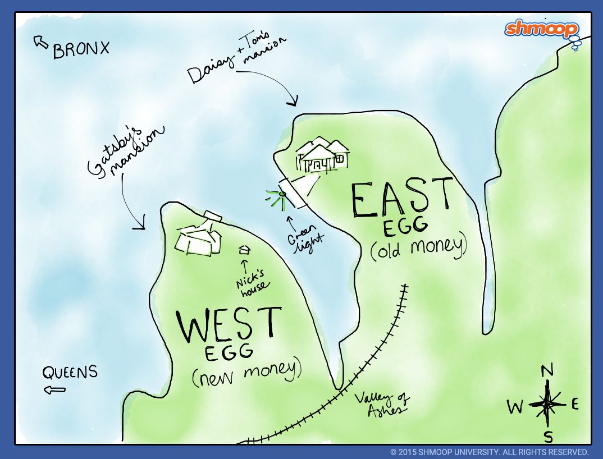

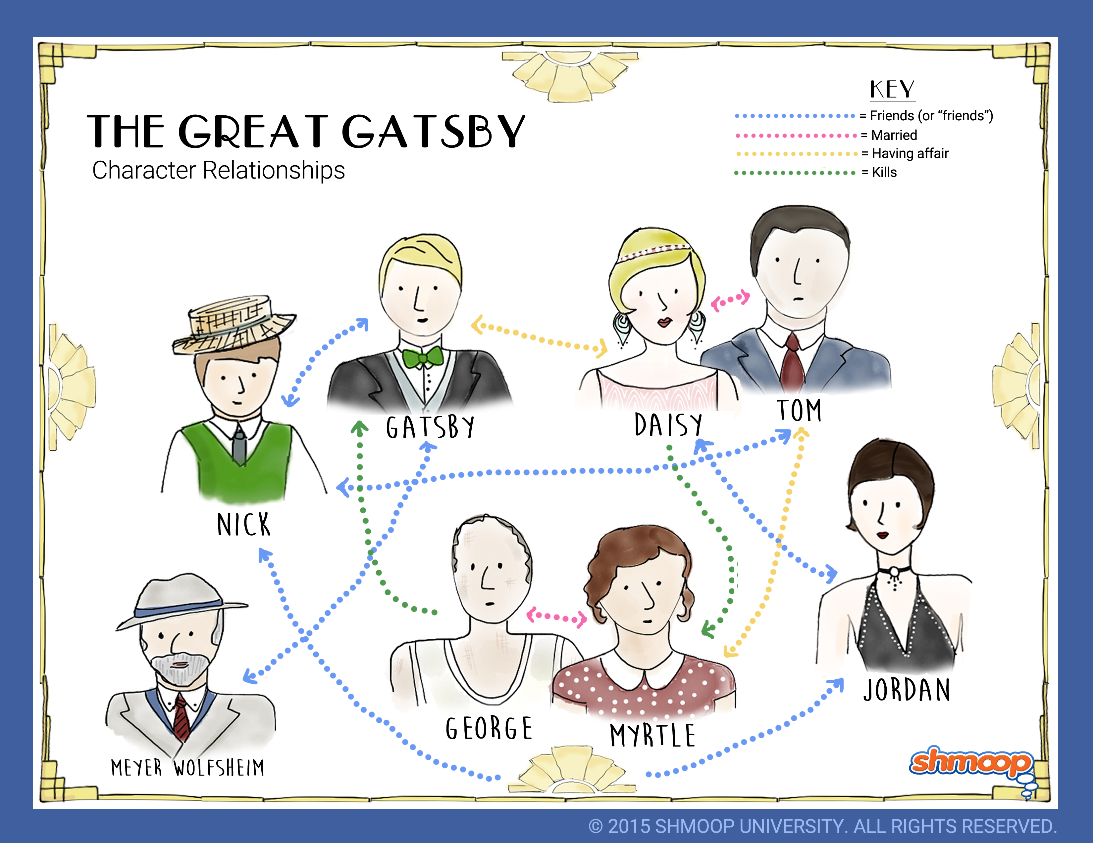
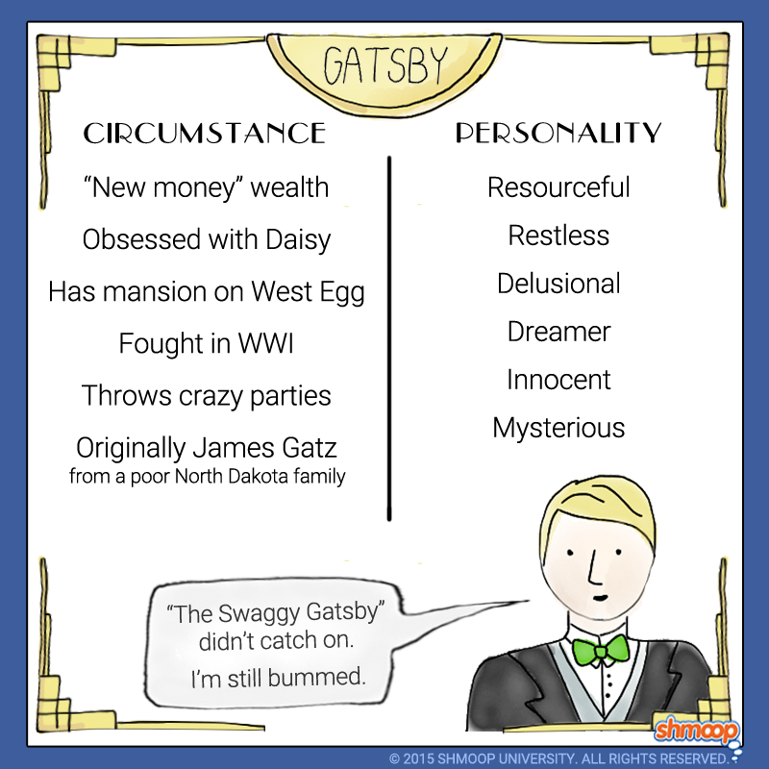
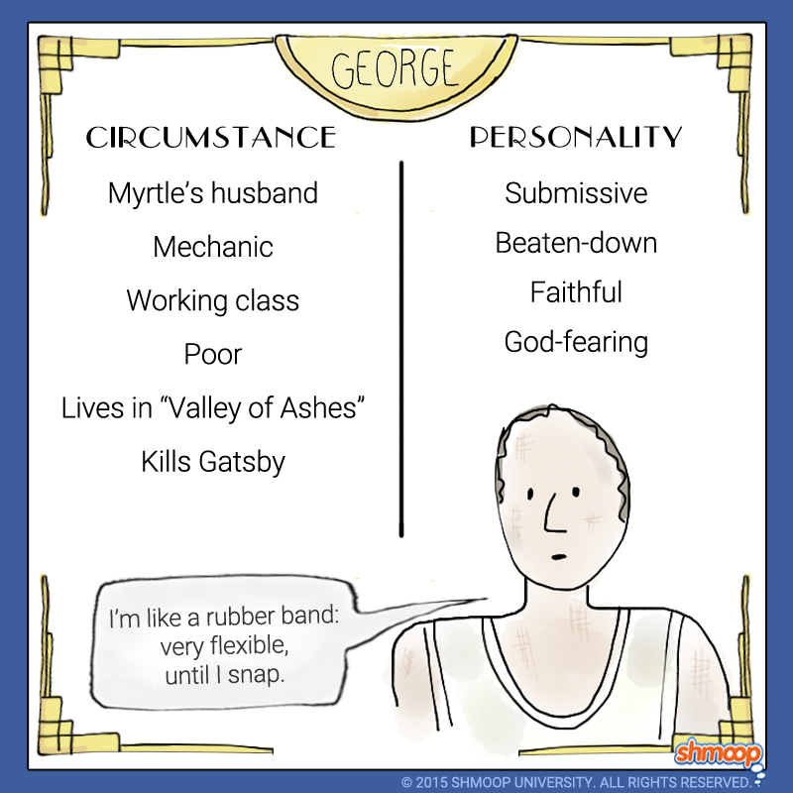
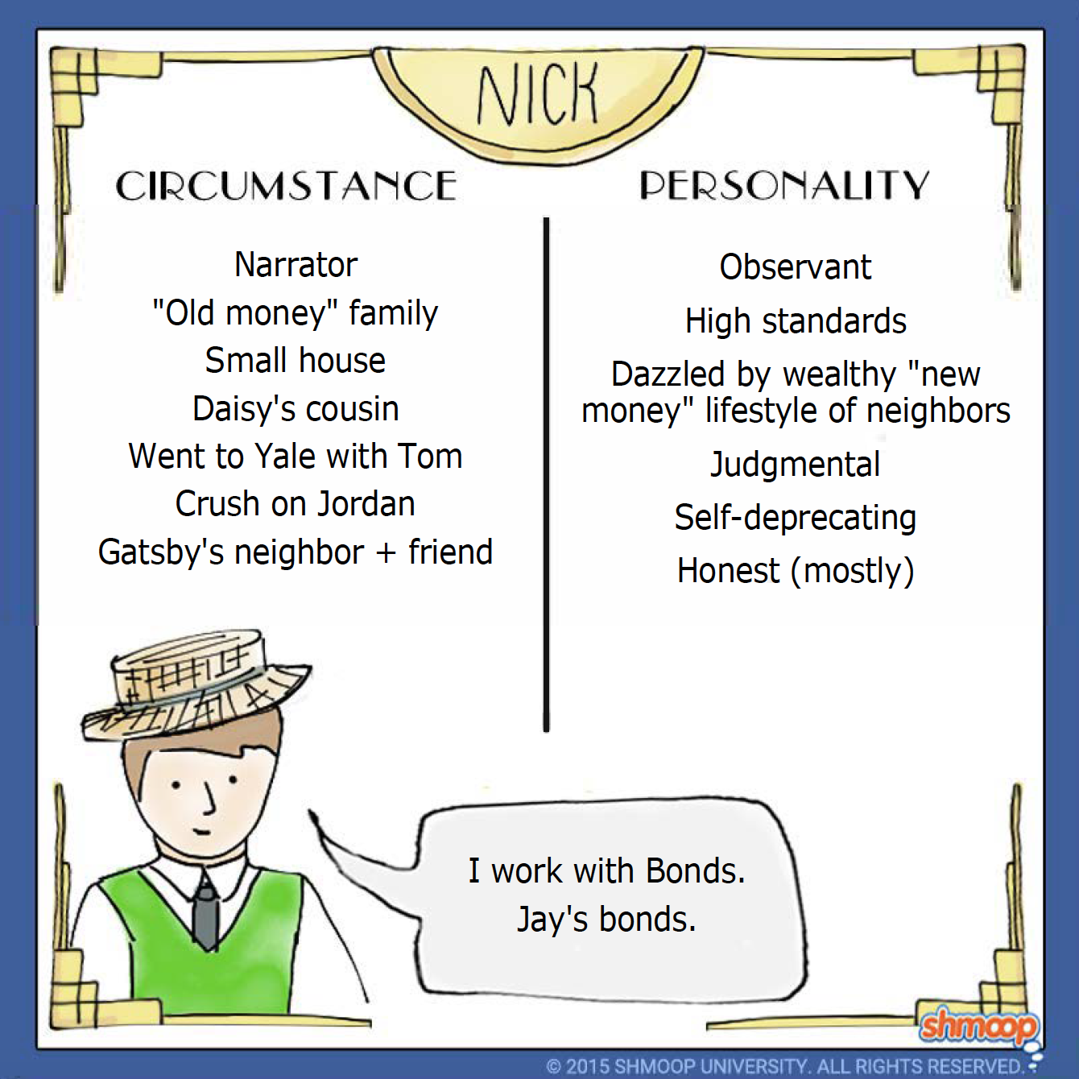
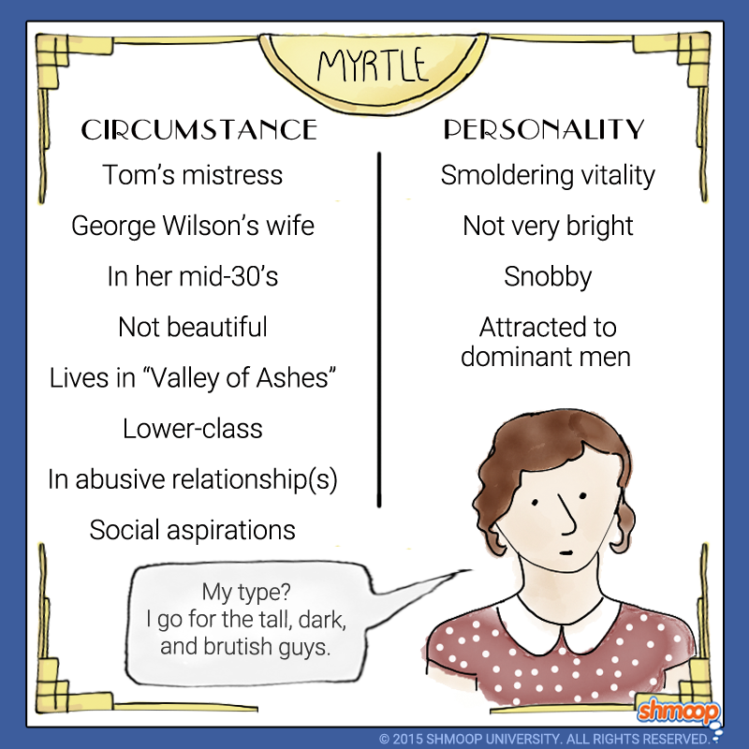
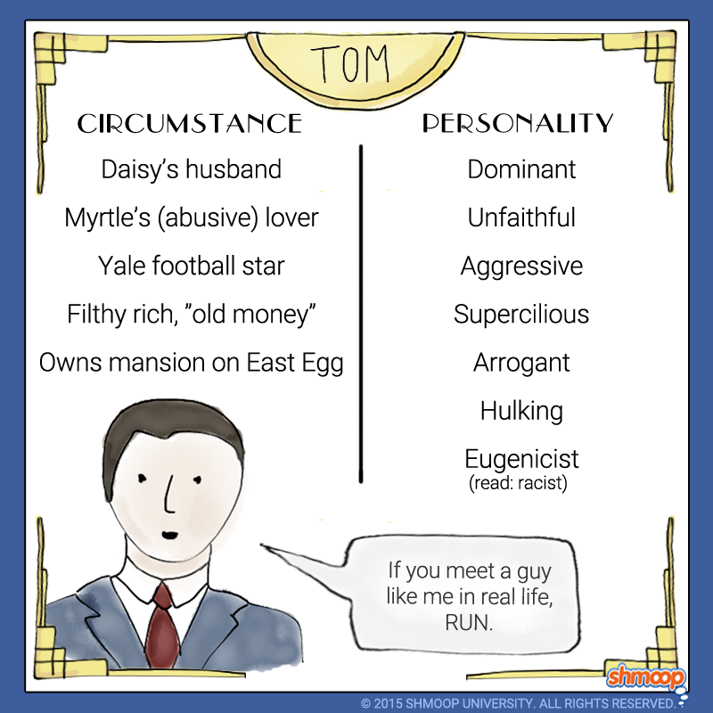
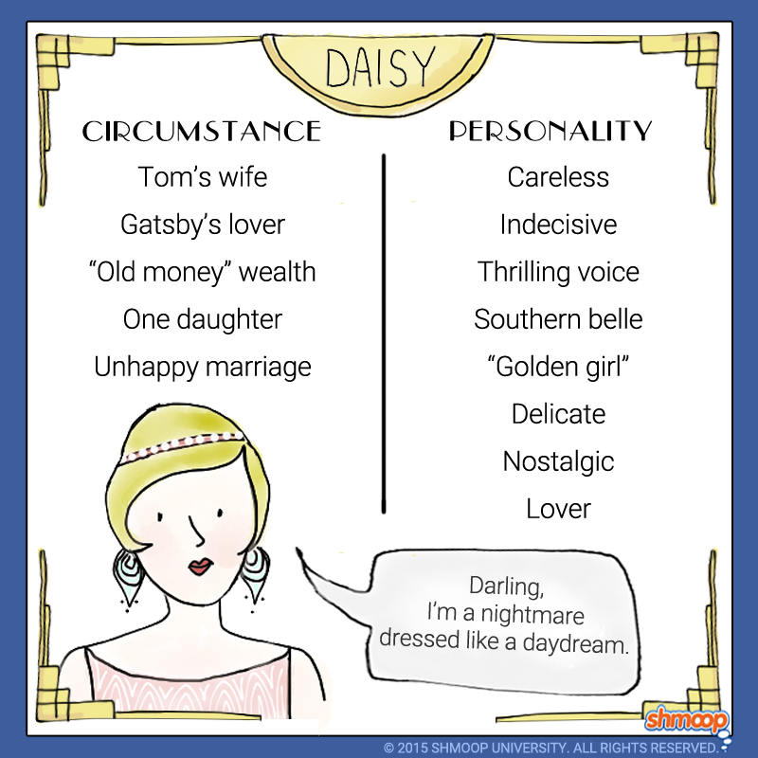

Differences between characters
Similarities between characters
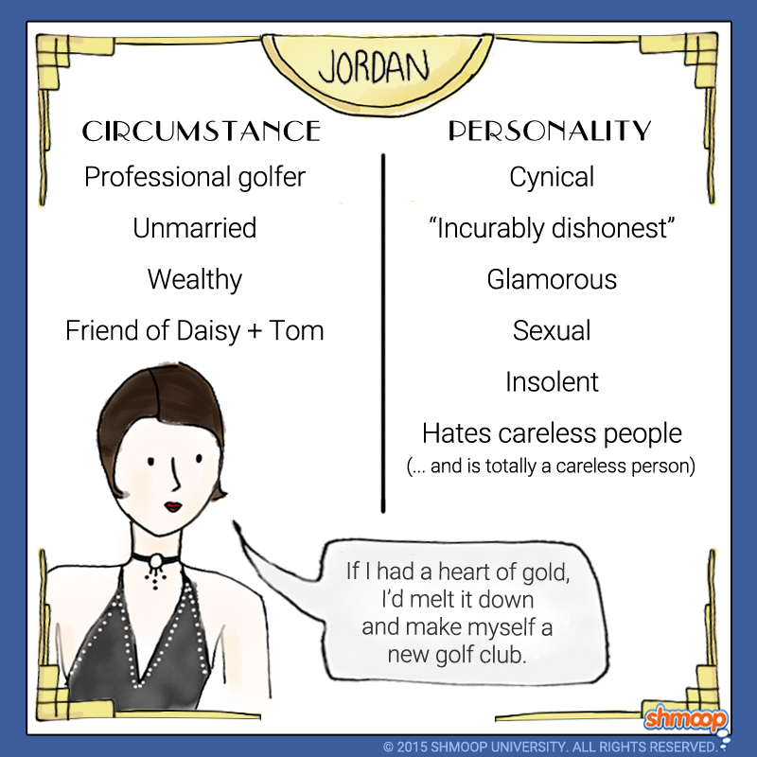
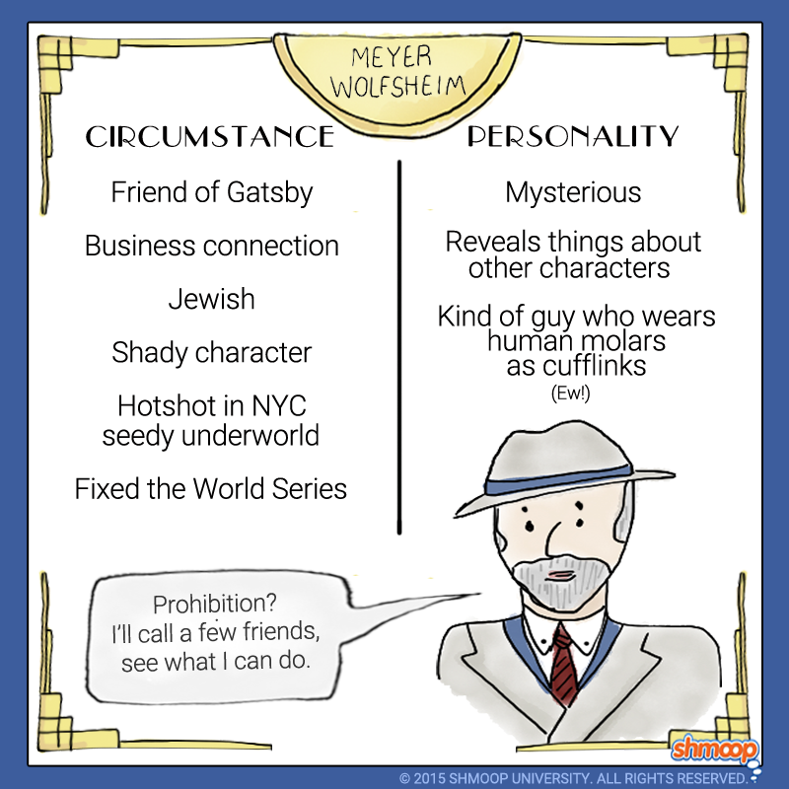
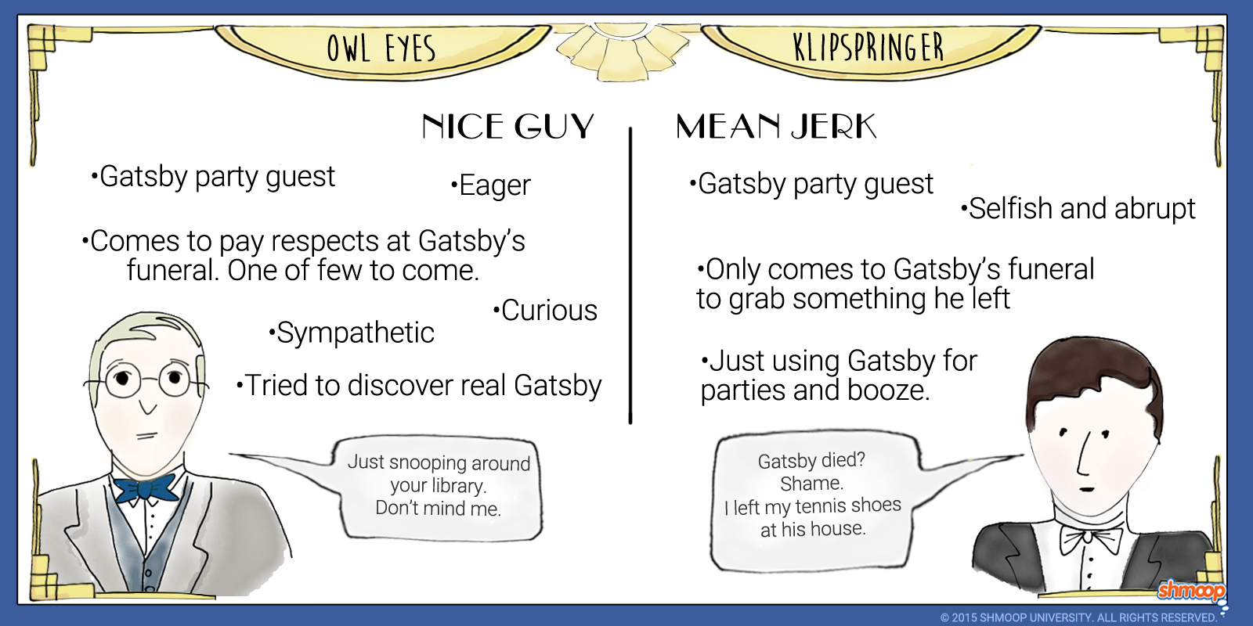

Chapter 1 | Notes:  List major conflicts, settings, characters, thematic topics, motifs, symbols, other literary devices, and important notes. | Significant Detail:  Sample Paper 2 IB Question: The memorable impact of novels and short stories arises from the careful and often brilliant creation of detail by their writers. Explore the role and impact of some significant details in the narrative. *Provide textual evidence and MLA in-text citation! | Compare/Contrast:  How is it similar or different to Charlotte Bronte’s Jane Eyre?

Chapter 2 | Notes:  List major conflicts, settings, characters, thematic topics, motifs, symbols, other literary devices, and important notes. | Significant Detail:  Sample Paper 2 IB Question: The memorable impact of novels and short stories arises from the careful and often brilliant creation of detail by their writers. Explore the role and impact of some significant details in the narrative. *Provide textual evidence and MLA in-text citation! | Compare/Contrast:  How is it similar or different to Charlotte Bronte’s Jane Eyre?
Chapter 3 | Notes:  List major conflicts, settings, characters, thematic topics, motifs, symbols, other literary devices, and important notes. | Significant Detail:  Sample Paper 2 IB Question: The memorable impact of novels and short stories arises from the careful and often brilliant creation of detail by their writers. Explore the role and impact of some significant details in the narrative. *Provide textual evidence and MLA in-text citation! | Compare/Contrast:  How is it similar or different to Charlotte Bronte’s Jane Eyre?

Chapter 4 | Notes:  List major conflicts, settings, characters, thematic topics, motifs, symbols, other literary devices, and important notes. | Significant Detail:  Sample Paper 2 IB Question: The memorable impact of novels and short stories arises from the careful and often brilliant creation of detail by their writers. Explore the role and impact of some significant details in the narrative. *Provide textual evidence and MLA in-text citation! | Compare/Contrast:  How is it similar or different to Charlotte Bronte’s Jane Eyre?

Chapter 5 | Notes:  List major conflicts, settings, characters, thematic topics, motifs, symbols, other literary devices, and important notes. | Significant Detail:  Sample Paper 2 IB Question: The memorable impact of novels and short stories arises from the careful and often brilliant creation of detail by their writers. Explore the role and impact of some significant details in the narrative. *Provide textual evidence and MLA in-text citation! | Compare/Contrast:  How is it similar or different to Charlotte Bronte’s Jane Eyre?

Chapter 6 | Notes:  List major conflicts, settings, characters, thematic topics, motifs, symbols, other literary devices, and important notes. | Significant Detail:  Sample Paper 2 IB Question: The memorable impact of novels and short stories arises from the careful and often brilliant creation of detail by their writers. Explore the role and impact of some significant details in the narrative. *Provide textual evidence and MLA in-text citation! | Compare/Contrast:  How is it similar or different to Charlotte Bronte’s Jane Eyre?

Chapter 7 | Notes:  List major conflicts, settings, characters, thematic topics, motifs, symbols, other literary devices, and important notes. | Significant Detail:  Sample Paper 2 IB Question: The memorable impact of novels and short stories arises from the careful and often brilliant creation of detail by their writers. Explore the role and impact of some significant details in the narrative. *Provide textual evidence and MLA in-text citation! | Compare/Contrast:  How is it similar or different to Charlotte Bronte’s Jane Eyre?

Chapter 8 | Notes:  List major conflicts, settings, characters, thematic topics, motifs, symbols, other literary devices, and important notes. | Significant Detail:  Sample Paper 2 IB Question: The memorable impact of novels and short stories arises from the careful and often brilliant creation of detail by their writers. Explore the role and impact of some significant details in the narrative. *Provide textual evidence and MLA in-text citation! | Compare/Contrast:  How is it similar or different to Charlotte Bronte’s Jane Eyre?

Chapter 9 | Notes:  List major conflicts, settings, characters, thematic topics, motifs, symbols, other literary devices, and important notes. | Significant Detail:  Sample Paper 2 IB Question: The memorable impact of novels and short stories arises from the careful and often brilliant creation of detail by their writers. Explore the role and impact of some significant details in the narrative. *Provide textual evidence and MLA in-text citation! | Compare/Contrast:  How is it similar or different to Charlotte Bronte’s Jane Eyre?

Sample IB Paper 2 Questions (A):
- Compare the use and function of seemingly insignificant detail in at least two works of prose fiction that you have studied.

- In at least two works of prose fiction that you have studied, discuss the presentation of competing ideas, hopes or visions and consider the effects created.

- Compare the presentation and function of villains or anti-heroes in at least two works of prose fiction that you have studied.

Sample IB Paper 2 Questions (B):
      - We often talk of characters arriving at some moment of epiphany; with reference to the novel, explain the means by which our attention is drawn to these moments and their impact within the work.

      - Authors are aware of the power of their works to shock the reader. Referring to at least two of the works in your study, explore some of the methods they have employed to do this.

      - In some works of fiction characters undergo change or even transformation. Compare how, and with what effect, the works of at least two writers you have studied depict such alterations.

