Name:_________________________________________________________________________________ CIRCLE BLOCK: 2A 3A 3B
George Orwell’s 1984 READING GUIDE
Directions: This is a daily homework guide to help you develop an understanding of the novel. In order to earn an advanced on the unit assessment evidence, this practice work must be complete.
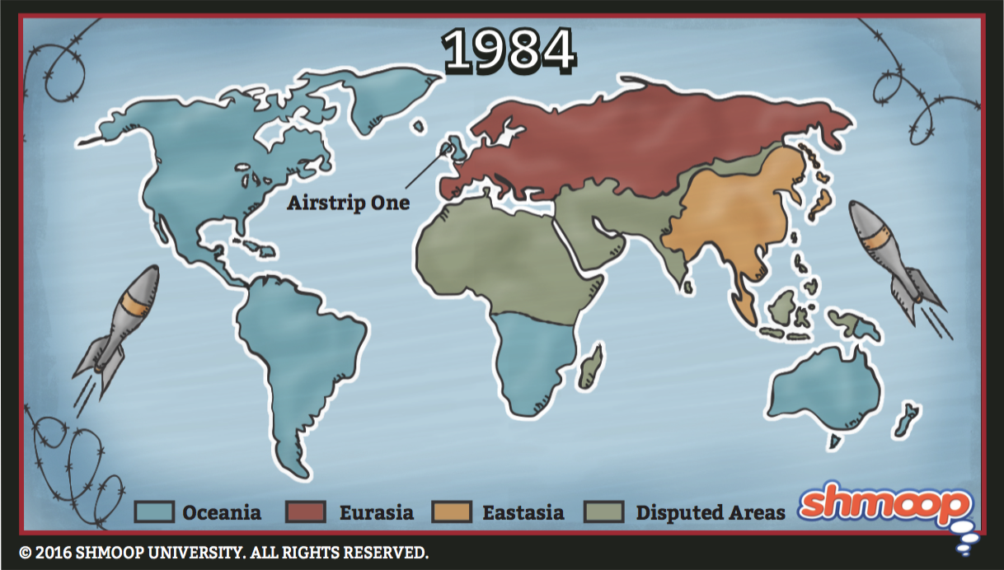
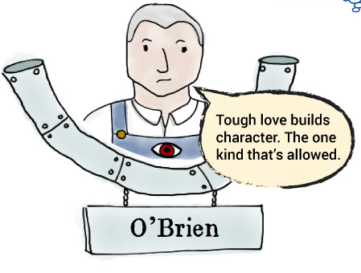
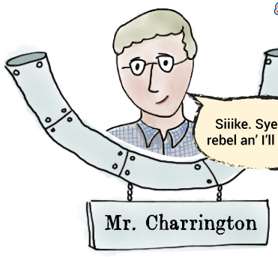

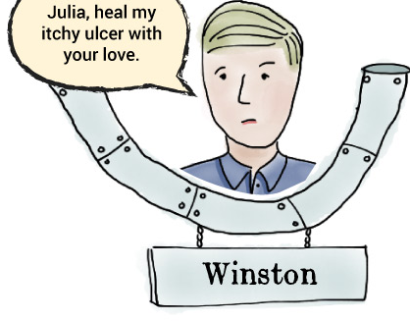
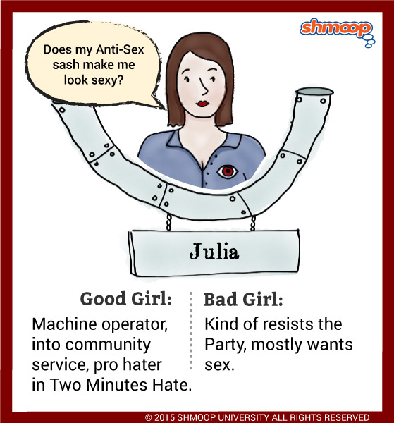
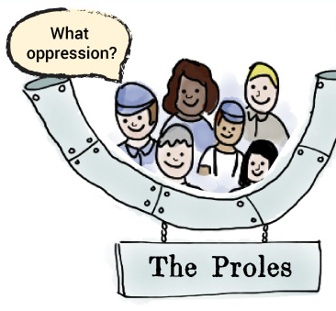

Pages 1-49, 309-323 |  | Notes:  List major conflicts, settings, characters, thematic topics, motifs, symbols, other literary devices, and important notes. |  | Paper 2 Assessment Prep:  Readers are often enticed by the idiosyncratic or quirky narrator. Compare how at least two authors that you have studied have crafted such distinctive voices, and to what effect.
 |  | Sample:  - Repetition of the party slogan “War is Peace. Freedom is Slavery. Ignorance is Strength”  - Symbol: “…Winston’s varicose ulcer symbolizes pain and stress emotionally and mentally  - Personification: “Even from the coin the eyes followed you...Always the eyes watching you and the voice enveloping you” (27). Emphasizes constant watchfulness, no privacy |  | Sample Thesis & Paragraph Response:  Thesis: Both Fitzgerald and Orwell craft distinctive voices to highlight the experience of an outsider struggling to live in a society with different morals and values.  Orwell uses third person limited point of view with attention to what Winston experiences to demonstrate his struggle with government standards and expectations. Winston is considered idiosyncratic or very individualistic because unlike other characters who obey the government’s complete lack of regard for humanity, Winston is a risk taker and believes in freedom and independence. For example, unlike others who mindlessly follow the unfair government, Winston writes, “Down with Big Brother” in his journal to break free from the constraints of society and gain his voice back. The use of third person point of view in which Winston isn’t directly able to share his thoughts to readers, but instead be told from someone else, further highlights the limited freedom he has and how difficult it is to overcome the constraints of his society. Orwell’s characterization of Winston through third person point of view reveals he is “quirky” because he chooses a different path than most people, which causes him to struggle as he is also attempting to evade the powerful government.  Similarly, Fitzgerald’s point of view functions the same way to highlight Nick as an outsider. Although Fitzgerald uses first person point of view instead of third person limited, Nick is characterized similarly to Winston because he, too, struggles with the immoral behavior he witnesses in New York. He does not seem to belong with…..  Plan your own response for 1984 and one other novel (brainstorm/outline/list or write full paragraph):
Pages 49-83 |  |  | Notes:  List major conflicts, settings, characters, thematic topics, motifs, symbols, other literary devices, and important notes. |  | Paper 2 Assessment Prep:  Compare the presentation and function of villains or anti-heroes in at least two works.
Pages 84-106 |  |  | Notes:  List major conflicts, settings, characters, thematic topics, motifs, symbols, other literary devices, and important notes. |  | Paper 2 Assessment Prep:  Compare the use and function of seemingly insignificant detail in at least two works.
Pages 107-129 | Notes:  List major conflicts, settings, characters, thematic topics, motifs, symbols, other literary devices, and important notes. |  |  |  |  | Paper 2 Assessment Prep:  Events in a plot elicit a variety of reactions from characters. With reference to the works of at least two writers you have studied, compare how they have highlighted, and made important to the works as a whole, reactions by different characters to certain events.
Pages 129-160 | Notes:  List major conflicts, settings, characters, thematic topics, motifs, symbols, other literary devices, and important notes. |  |  |  |  | Paper 2 Assessment Prep:  The impact of a work is affected by the reliability of its narrator. With reference to the works of at least two writers, compare the techniques used to enable readers to assess narrator reliability, and how far it matters.

Pages 160-183 | Notes:  List major conflicts, settings, characters, thematic topics, motifs, symbols, other literary devices, and important notes. | Paper 2 Assessment Prep:  Though plot is said, at its simplest level, to be a sequence of events, what truly distinguishes prose fiction is the use of narrative disruption: impediment, detour, diversion, or digression. How have writers created narrative disruption and to what effect?
Pages 183-230 | Notes:  List major conflicts, settings, characters, thematic topics, motifs, symbols, other literary devices, and important notes. | Paper 2 Assessment Prep:  A plot twist intrigues both writer and reader, but the seeds of that turn of events must be sown early to ensure its plausibility. Compare the ways in which at least two authors you have studied have prepared the reader for these plot twists.

Pages 231-269 | Notes:  List major conflicts, settings, characters, thematic topics, motifs, symbols, other literary devices, and important notes. | Paper 2 Assessment Prep:  In at least two works, discuss the presentation of competing ideas, hopes, or visions and consider the effects created.
Pages 269-308 | Notes:  List major conflicts, settings, characters, thematic topics, motifs, symbols, other literary devices, and important notes. | Paper 2 Assessment Prep:  In some works of fiction characters undergo change or even transformation. Compare how, and with what effect, the works of two writers depict such alterations.

