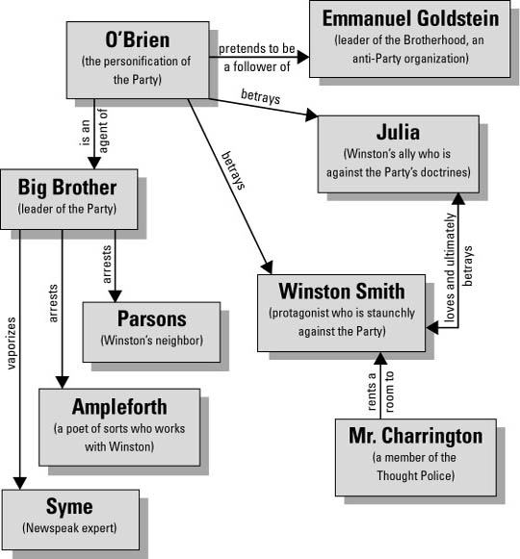
Government: Totalitarian political regime that rules all of Airstrip One—the land that used to be called England—as part of the larger state of Oceania.
Setting:
1984 | What is that?
Party Slogans
Telescreen
Thought Police
Ministry of Truth
Ministry of Peace
Ministry of Love
Ministry of Plenty
Proles
The Brotherhood

